Problem statement: Perform Connecting two PCs /computer using peer to peer in Packet Tracer.
Objective: To understand how to Connect two PCs /computer using peer to peer.
Description: Steps for practical of network design, IP configuration and connectivity
Step 1: Select, Drag and Drop 2 Pc from End Devices.
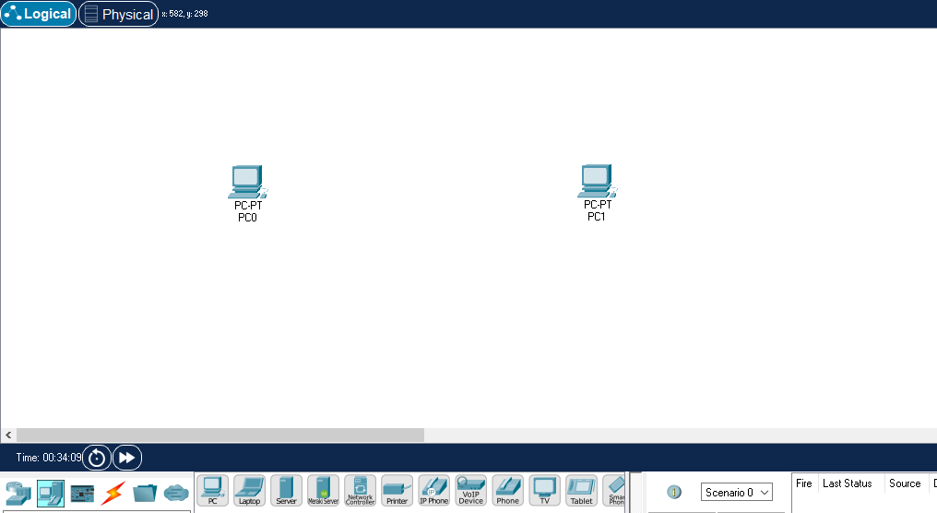

Step 2: Select copper cross over cable from connection. And connect through FastEthernet.
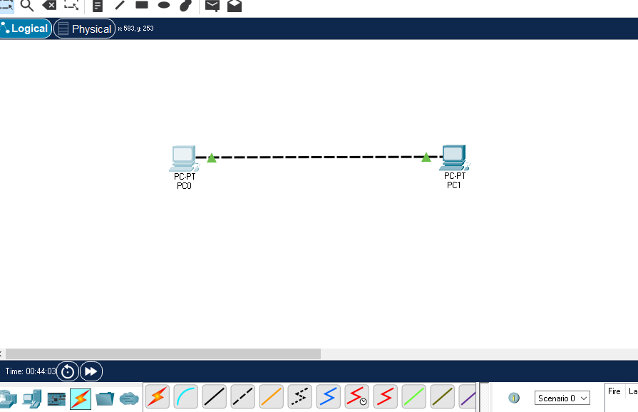

Step 3: Configure IP address of PC0 and PC1.
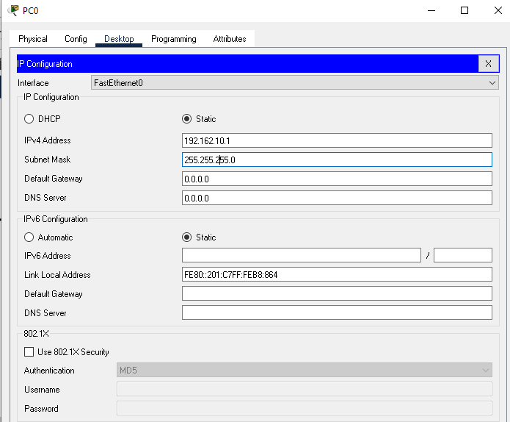
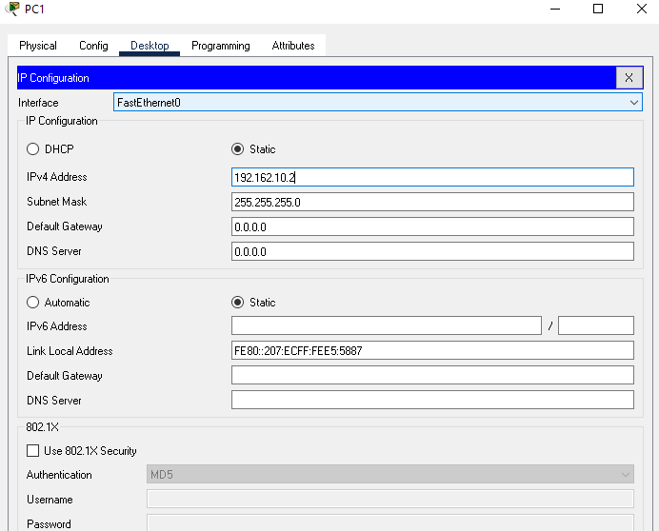
now IP configuration PC0 and PC1 is done.

Step 4: Open command prompt of PC0 and enter ping command for PC1.
Similarly enter ping command prom PC1 for PC0.
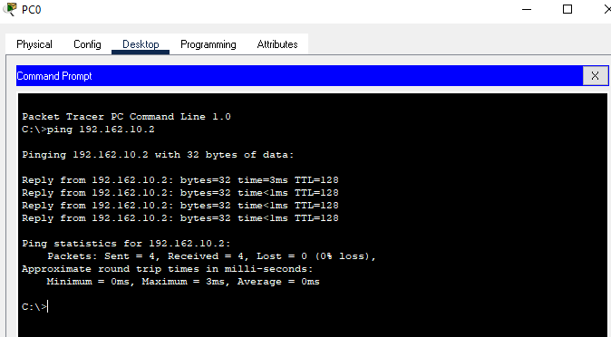
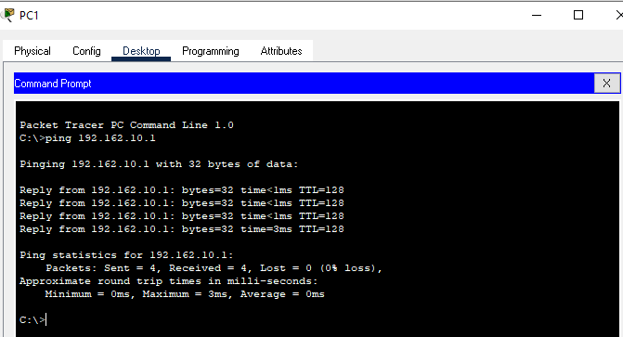
Now Pc0 and Pc1 is connected.

